Hotel Room Booking System
Project submitted to the
SRM University – AP, Andhra Pradesh
for the partial fulfilment of the requirements to award the degree of

Bachelor of Technology
In
Computer Science and Engineering
School of Engineering and Sciences
Submitted by
A. javeed AP23110010947
D. Hanumanth Sai Kumar AP23110010954
K. Nandan Chowdary AP23110010815
P. Koushik AP23110011500



SRM University – AP
Neerukonda, Mangalagiri, Guntur
Andhra Pradesh – 522 240
[December, 2025]

Table of Contents
- Abstract
- Introduction
- System Requirements
- Technology Stack
- System Analysis
- System Design
- Component Descriptions
- Screenshots & Output
- Conclusion
- References
- Appendix

Abstract

This project report presents the design and implementation of a frontend-only Hotel Room Booking System developed using modern web technologies. The system focuses on delivering an intuitive and responsive user interface to browse rooms, view details, and manage mock bookings using local or mock data. The project demonstrates component-based architecture, UI/UX principles, and interactive functionality without backend integration. The structure, modules, testing, and outcomes are documented in detail.

1. Introduction
1.1 Background
Hotel room booking systems have become a necessity for modern hospitality services. While full-stack systems manage real-time availability, a frontend system plays a crucial role in providing seamless user experience. This project simulates the UI/UX and navigational flow of a hotel booking system using only frontend technologies.
1.2 Problem Statement
Many learning-level or prototype projects require a working interface without the complexity of backend logic or database integration. The objective is to create a realistic booking system interface that demonstrates design, interactivity, and frontend engineering skills.
1.3 Objectives
- To design a responsive hotel booking user interface.
- To implement interactive components for browsing and viewing room details.
- To simulate user login, registration, and bookings using mock data.
- To demonstrate modern frontend architecture using components, contexts, and routing.
1.4 Scope
- Includes: UI pages, navigation flows, context-based state management, mock data handling.
- Excludes: Real backend, payment APIs, real authentication.

2. System Requirements
2.1 Functional Requirements
- Users should be able to browse rooms.
- Users can view room details.
- Basic login and registration UI.
- Booking form (frontend-only, stored in mock or local storage).
- Page navigation through router.
2.2 Non-Functional Requirements
- Responsive design.
- Fast performance.
- Easy navigation flow.
- Component reusability.
2.3 Hardware Requirements
- A computer with modern web browser.
2.4 Software Requirements
- Code Editor (VS Code)
- Node.js & npm
- Browser (Chrome/Firefox)
- Vite (Project bundler)
- Tailwind CSS

3. Technology Stack
- HTML – Structure of the application.
- CSS / Tailwind CSS – Styling and responsive layout.
- JavaScript (ES6+) – Logic for interactivity.
- React.js – Component-based UI library.
Tools Used
- Vite (fast dev server)
- ESLint (linting)
- PostCSS (styling processor)

4. System Analysis
System analysis identifies the needs of the users and outlines how the proposed system will address them. For the Hotel Room Booking System, the goal is to simplify the room browsing and booking experience through an intuitive frontend interface.

4.1 Existing System
In many conventional hotel booking setups, users struggle with issues such as unclear room availability, slow manual processes, and outdated user interfaces. These limitations reduce user convenience and make the booking experience inefficient.

4.2 Proposed System
The proposed system provides a clean, modern, and responsive UI where users can easily browse rooms, view details, log in, and manage their bookings. It eliminates manual effort, improves user experience, and ensures quick navigation using a fully frontend-based approach built with React and Tailwind CSS.

4.4 Advantages
- User-friendly interface
- Quick navigation
- Modern responsive design

5. System Design
5.1 Navigation Flow
- Home → Rooms → Room Details → Booking
- Login → Register → Home
- My Bookings Page (Mock)

5.2 Component Hierarchy
App.jsx
- Root component responsible for routing and rendering all primary pages
- Contains:
  - NavBar.jsx
  - Pages
  - Contexts
Pages
- HomePage.jsx
  - Displays featured rooms
  - Uses:
    - RoomCard.jsx (repeated for each room)
- RoomsPage.jsx
  - Shows list of all available rooms
  - Uses:
    - RoomCard.jsx (for displaying each room)
- RoomDetailsPage.jsx
  - Shows full details of a selected room
  - Contains:
    - Image Gallery Component (optional)
    - Booking Button Component
- LoginPage.jsx
  - Contains:
    - Input Fields
    - Submit Button
- RegisterPage.jsx
  - Contains:
    - Input Fields
    - Submit Button
- MyBookingsPage.jsx
  - Displays user’s bookings
  - Uses:
    - BookingCard.jsx (optional)
- NotFoundPage.jsx
  - Page displayed for invalid or unknown routes

Contexts
- AuthContext.jsx
  - Manages authentication state
  - Provides login, logout, and user session handling

6. Component Descriptions
- Home Page
  - Displays hotel introduction
  - Shows featured rooms
  - Includes promotional banners or highlights
- Rooms Page
  - Lists all available rooms
  - Uses the RoomCard component for each room
- Room Details Page
  - Shows complete room description
  - Displays price, amenities, and images
  - Includes a booking button
- Booking Form
  - Performs frontend validation
  - Uses local state or mock storage for temporary data
  - No backend database interaction
- Login & Registration Pages
  - Provides UI screens for authentication
  - Uses AuthContext for managing login state
- My Bookings Page
  - Shows user’s mock booking history
  - Used only for demonstration purposes
- Error Page (404)
  - Custom “Page Not Found” interface
7. Screenshots & Output

7.1 Home Page
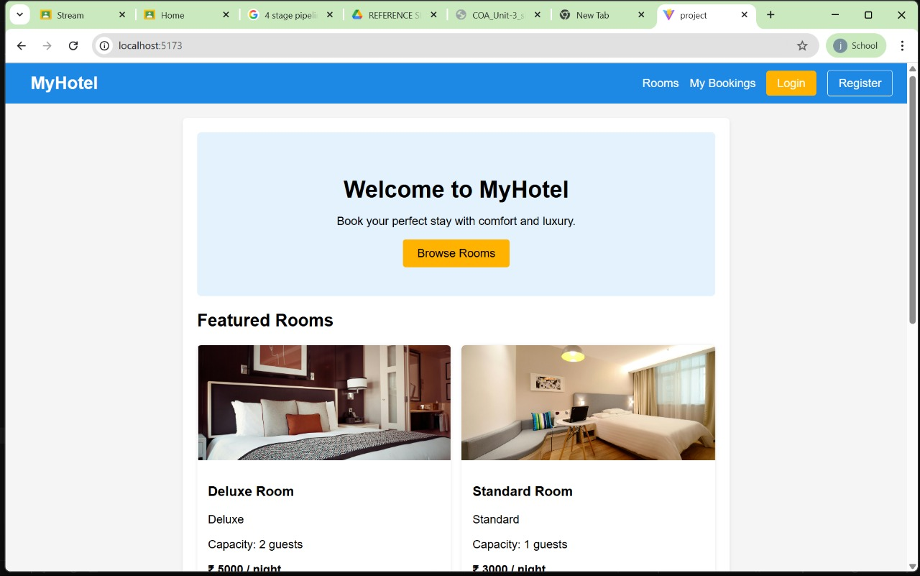7.2 Rooms Page
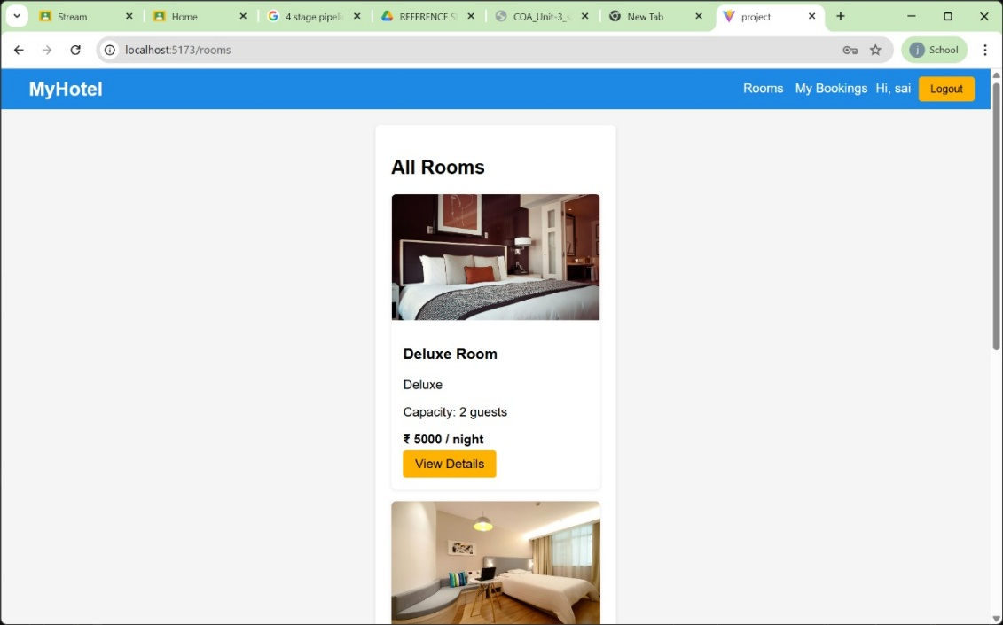

7.3 Room Details Page
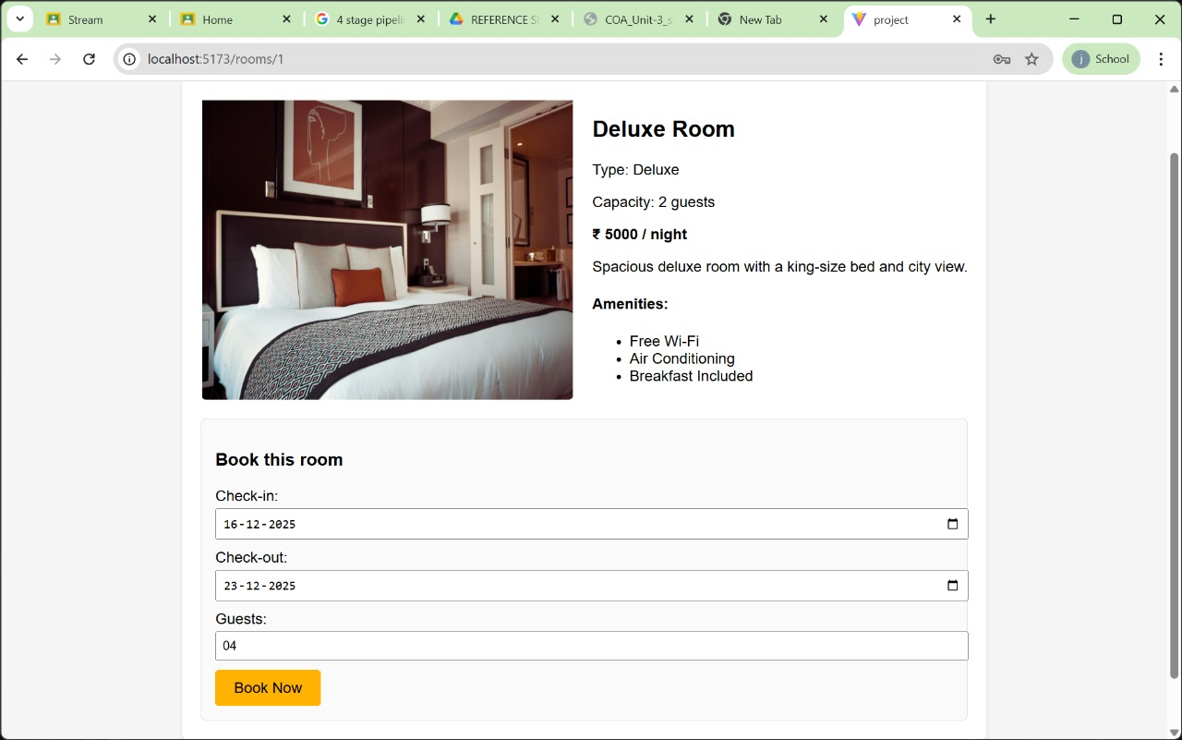
7.4 Login & Register Pages
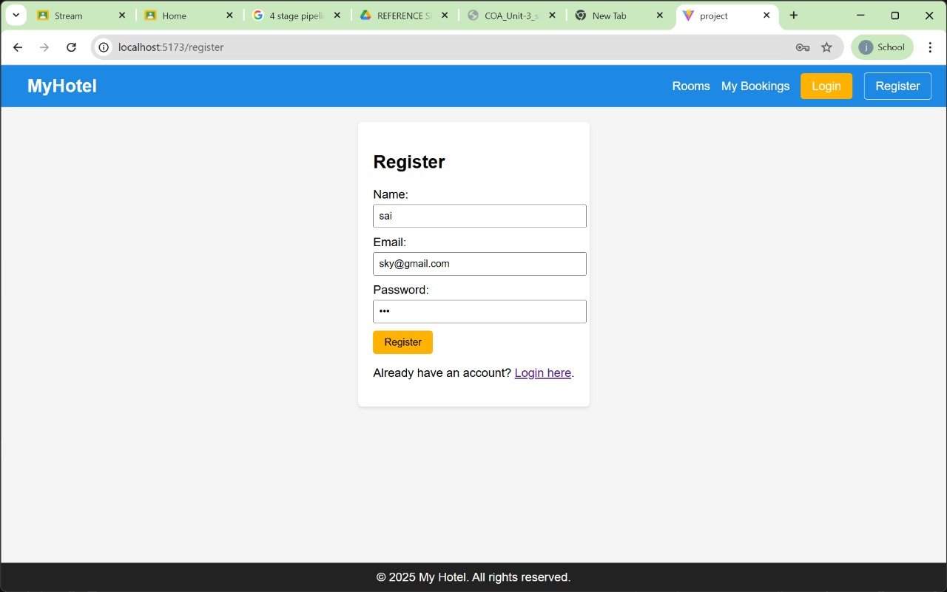
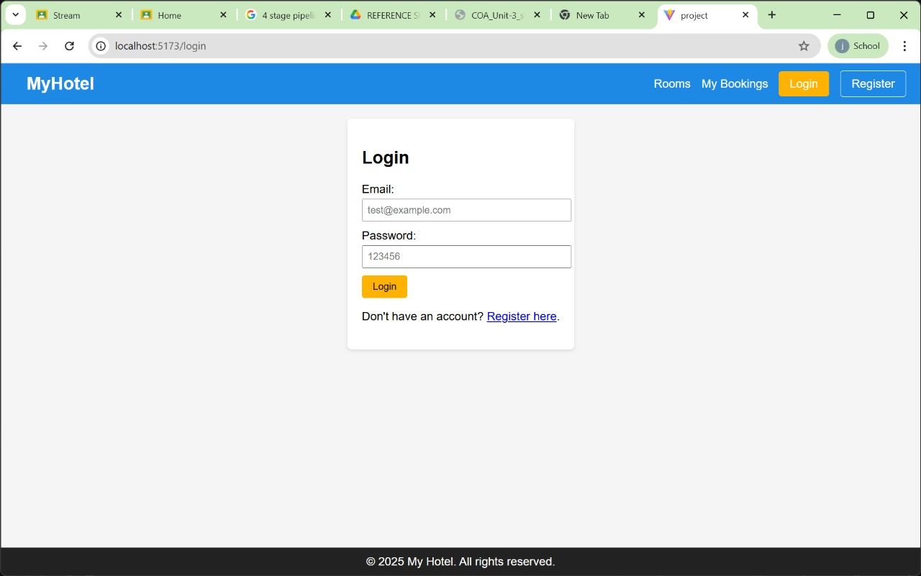
7.5 My Bookings Page
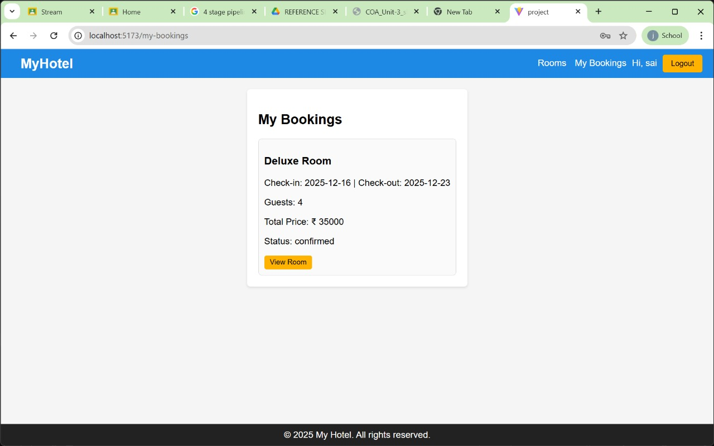

8. Conclusion
This frontend hotel booking system demonstrates the design of a modern, responsive, and component-based UI that resembles a real-world booking platform. Despite being frontend-only, it achieves good interactivity and organization using React, Tailwind CSS, and Context APIs.

9. References
- React Documentation
- Tailwind CSS Docs
- MDN Web Docs
- Vite Documentation

10. Appendix
10.1 Git repositories link:
(Add code snippets or attach project bundle)

